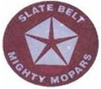

Officers-2014

President: Rick Hageman Vice President: Bruce Ott 610-863-6900
bigdawg1@ptd.net

Treasurer: Tim Sparrow 610-216-3844 Secretary: Vince Ruocco 570-839-2555
reddodgedemon_72@yahoo.com jvruocco@ptd.net

Webmaster: Charlie Copley Club Website
webmaster@slatebeltmightymopars.com slatebeltmightymopars.com

Members present: 14 Date:September 2014
Meetings will be held on the second Monday of the month.
Next Meeting will be on October 13, 2014 at 7:30 pm at Dotta’s showroom.
Meeting Minutes:
Treasurer’s Report:
Disbursement for the month was the rental fee to lease the pavilion at Beltsville. Receipts include sale of a club jacket and new membership dues.
Discussions:
- The focus of discussion at the last meeting was the action on the part of the Highwinders to exclude our club from any Stick Reunion show participation. Rick has had several discussions with the Highwinders president and the conclusion was to exclude our club. On September 24, 2014 Rick sent an email to all members with an email address, that will be attached to this newsletter for members not having an email address, indicating the sequence of events regarding the Highwinders.
- At the next meeting the club will vote on whether we take legal action against the Highwinders and also vote on whether our club sponsor a fall car show inviting all makes and model cars.
- This is just another reminder of the Club’s picnic at Beltsville Lake on October 5, 2014. If you plan to attend contact Rick at 610-509-3100.

Check out the following Cruises and Car Shows:
- Burger King, Stroudsburg by the Stroud Mall every Friday Night
- Trolley Shops, Bangor, PA now on Sundays 2:00 – 4:00 pm
- October 4th Lehman Township Community Day at Mount Laurel Center 1 – 5 pm. For more information call Joe Peritor 570-588-1446.
- October 4th Bangor High School Select Choir Car Show 10:00am – 3:00pm. For more information call Zachary Miller 610-588-9529
- October 5th Ken Pollock Auto Dealerships Octoberfest Car and Truck Show at Rear 145 Old Newport Street Nanticoke, PA 18634 for more information call Mike Yalch 570-735-7953.
- October 5th Dream Come True at Becky’s Drive In on Route 248 Berlinsville. For additional information call Wanda 610-767-8434.
- October 11th Salisbury Block and Tackle Show at Salisbury Middle School, 3301 Devonshire Rd., Allentown, PA for more information contact Dan Bohry 484-357-3385.
- October 12, 2014 Autumnfest and Car Show at North Catasaqua Park 11:00am – 4:30 pm. For more information call 484-560-1938.
- October 18th Flemington Speedway Car Show at Hunterdon County Fairgrounds,South County Park, Route 179, Ringoes, NJ for more information call 484-221-5052.
- October 19th Octoberfest Car Show at American Legion Post 927 Route 209, Gilbert, PA for more information contact Ed 610-657-6196.
New Members:
The Slate Belt Mighty Mopar Club Welcomes the following New Member:
Jim Rattray - 1968 Plymouth GTX
2001 Dodge Dakota
2001 Dodge Durango
Cars for Sale:

1969 Dodge Coronet 440 2 Door Hardtop
318, auto, PS,MB,AM/FM CD, dual exhaust, flowmasters, 15” magnum 500s with excellent tires, does not need body panels, upgraded drive train available that includes 360 engine with magnum heads, 727 trans., 8 ¾ rear complete with drive shaft. Asking 18k or 16k without the extra drive train. Call Erik 908-310-2281 or erik70rt@yahoo.com.

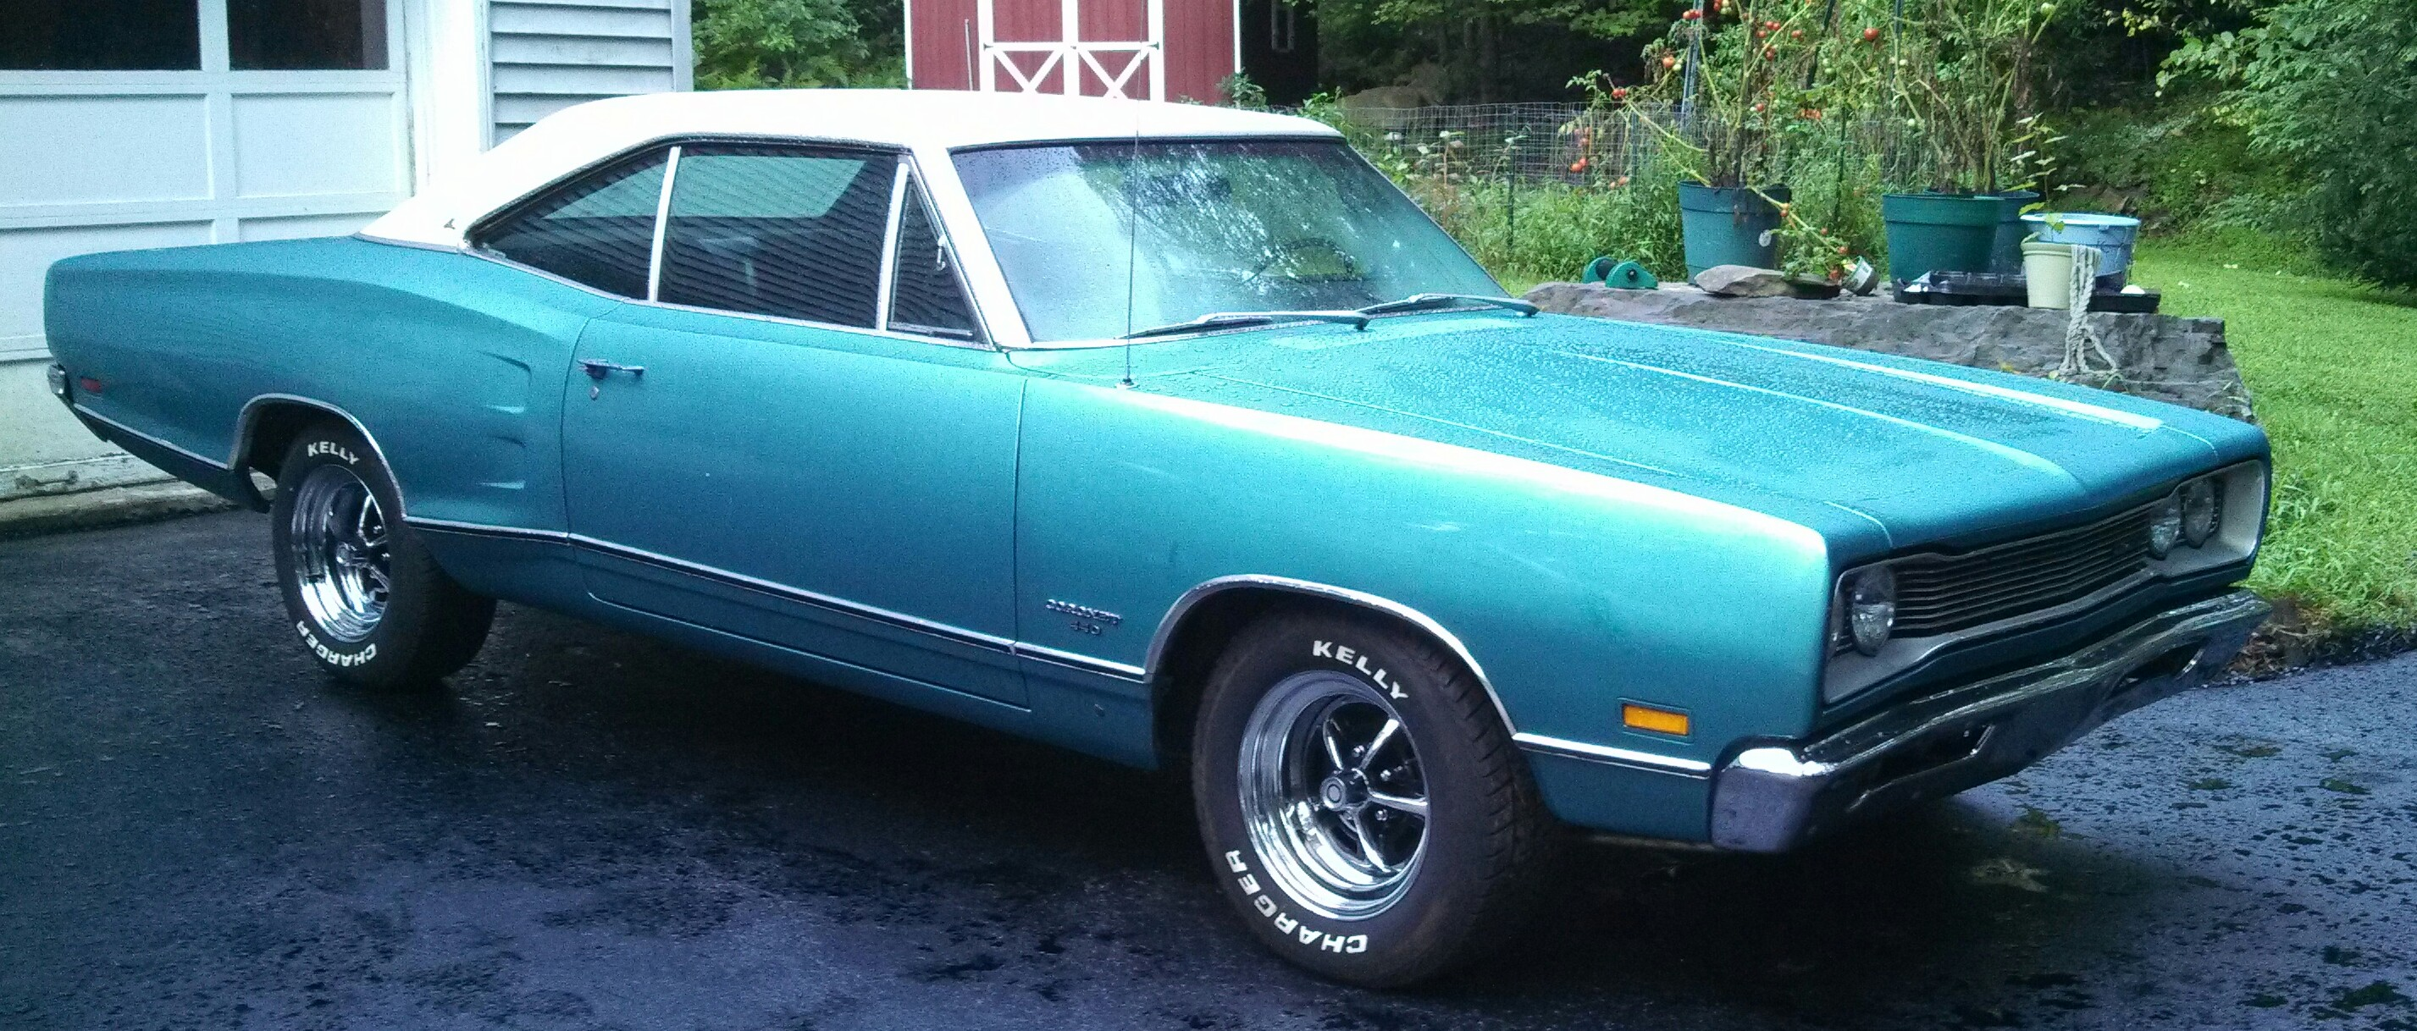
1970 Dodge Superbee
Numbers matching 440 Six Pack, column shift automatic, PB,PS less than 19,000 original miles, Ram Charger Hood, Rally Clock, Rally Wheels, original polyglas tires Hemi orange.Asking $50,000. Partial trade accepted. Contact Randy at 570-688-1057.
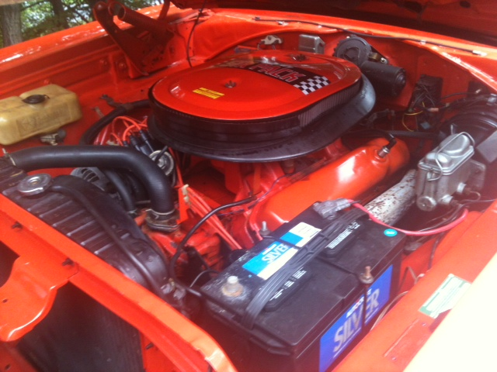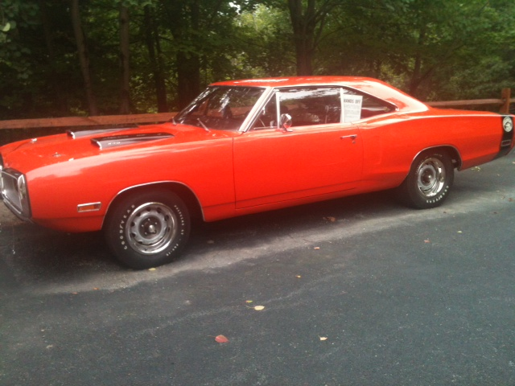
1985 Dodge Commander W150
318 Auto Trans.,4WD, Meyers Power Angle Plow ( Good Hydraulics ), body rough, good mechanical condition, needs minor mechanical work, 120,000 miles, not licensed and cannot be driven on a road or field $1,500. Call Jim Rice 610-739-1965.

Parts for Sale:
- Small Bolt to Big Bolt pattern wheel adapters $100. Call Tim 610-216-3844.
- 1935 Dodge pickup complete rear and transmission, best offer. Call Bruce 610-863-6900.
- E body parts for sale at reasonable prices call Mike 570-620-1283
- Set of traction bars for an early 70s A Body that were on a ’72 Duster. Make offer to Tim Hageman by contacting him at this email address tjhtrain@yahoo.com
- Tony Petrucci is clearing out his inventory of cars and parts that include A,E, B and C Body parts at great prices. Contact Tony at 610-844-2697.

Parts Wanted:
- Looking for the following part from a 1968 or 1969 B body
Drivers side splash shield that fits between the inner fender and the cowl.
Call Vince at 570-839-2555
Check it out:
The best Mopar website on the internet www.moparts.com for selling and looking for parts and cars.
Another website to explore is www.dodgecharger.com also for selling parts, buying parts and technical advice for your classic Mopar.
Don’t crush them. Restore them.
*** Members wishing to have their car featured in the newsletter should send a photo and a brief description of their car along with the modifications and special features to Vince Ruocco at jvruocco@ptd.net or call 570-839-2555.
Members who still have not paid their annual club dues of $20 should submit your payment to Tim Sparrow at the next meeting or mailing it to the club at P.O. Box 415, Wind Gap, PA 18091.
Your Mopar Club is always striving to reduce our operating costs. One area that needs attention is to reduce our mailing and processing cost regarding our monthly newsletter. We are requesting members who receive their monthly newsletter by mail and have an email address should report their email address to Vince Ruocco at jvruocco@ptd.net. Reducing the mailing of newsletters eliminates postage and ink cartridge costs.
Hope to see you at the next meeting on October 13th at Dotta’s showroom at 7:30 pm.

